IRootLab Tutorials
Mann-Whitney “U”-test per wavenumber
Julio Trevisan
30/Jan/2012

This document is licensed under a Creative Commons Attribution-NonCommercial-ShareAlike 3.0 Unported License.

Introduction 1
Conventions 1
Tutorial 1
The dataset 1
Preparation 3
One-step way 5
Alternative way 7

Introduction
This tutorial shows how to perform a Mann-Whitney “U”-test per wavenumber and get a curve similar to a loadings curve.

Loading data
This tutorial uses Ketan’s Brain data[1], which is shipped with IRootLab.

- At MATLAB command line, enter browse_demos
- Click on “LOAD_DATA_KETAN_BRAIN_ATR”
- Click on “objtool” to launch objtool
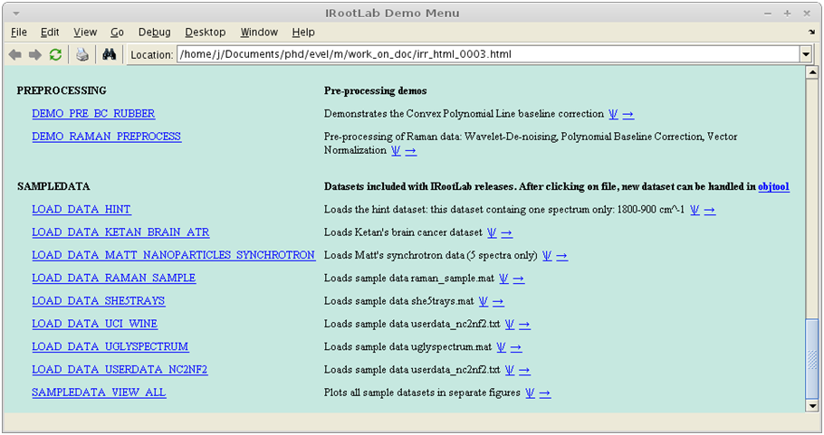
2
3

Preparation
This step creates a Feature Subset Grader (FSG) object. A FSG object evaluates features (wavenumbers) according to some criterion (in our case, the criterion will be the U-test).

- Click on Feature Subset Grader
- Click on New…
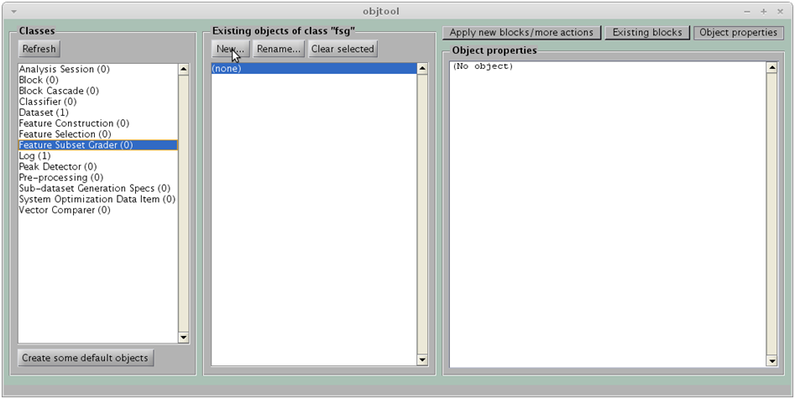
1
2

- Click on U-test
- Click on OK
Note – You can use another test instead of the U-test. However, the U-test is theoretically more appropriate than, for example, the T-test, because the data variables probability distributions may be skewed, bimodal etc. So, the U-test is appropriate because it is non-parametric: it does not try to guess any parameters of an assumed distribution. In opposition, the T-test assumes normal (Gaussian) distribution.

Fisher’s score is the between-class variance divided by the within-class variance;
ANOVA is the multi-class equivalent of the T-test;
Variance calculates the variance of each wavenumber;
MANOVA is not appropriate for the context. It is a multivariate test, whereas we are interested in univariate measures here.
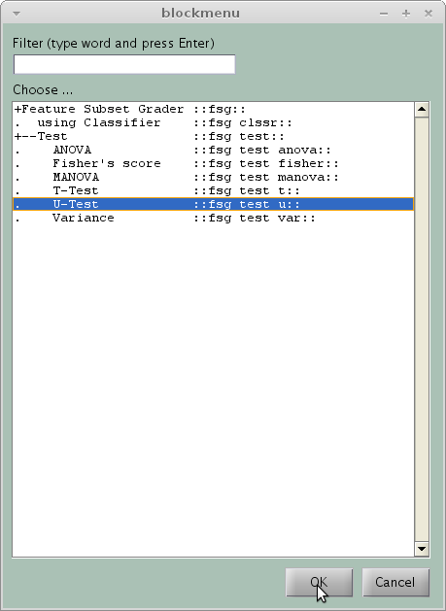

- Click on OK
Note - Because the checkbox is checked, the curves obtained will have –log₁₀(p-value) in the y-axis, rather than the p-value itself. This form is convenient because it transforms the p-value into a “significance measure”. The lower the p-value, the higher the significance.

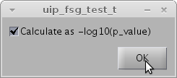

An object called fsg_test_u01 should appear in the middle panel:
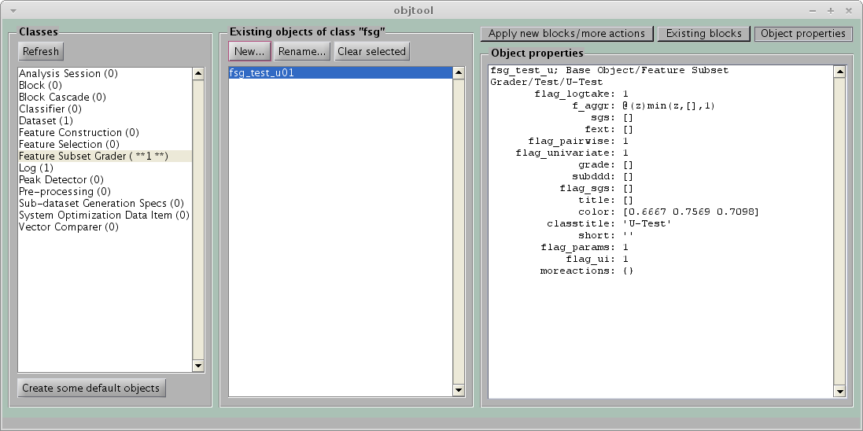

One-step way
This way is quicker, but will draw the curve only (see also Alternative way below).

- Click on Dataset
- Click on Apply new blocks/more actions
- Click on Feature grades
- Click on Create, train & use
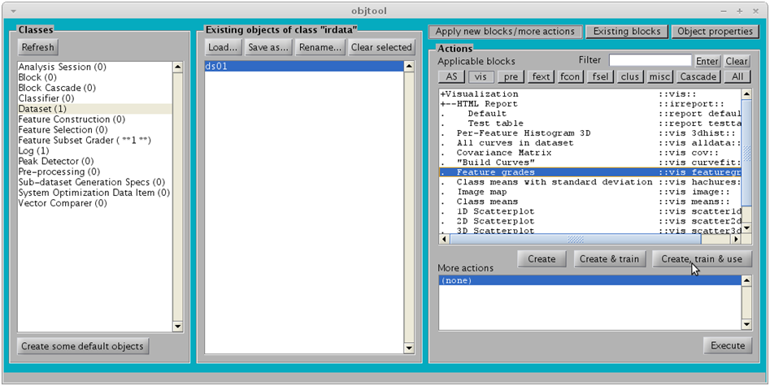
16
17
18
19

- FSG: specify fsg_test_u01 created previously
- Dataset for hint is optional. If specified, a dashed black spectrum will be drawn on the background of the figure. The objective is to help with the biochemical interpretation of the U-test per wavenumber curve.
- Click on OK
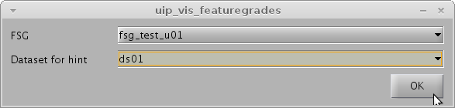

The following figure should appear:
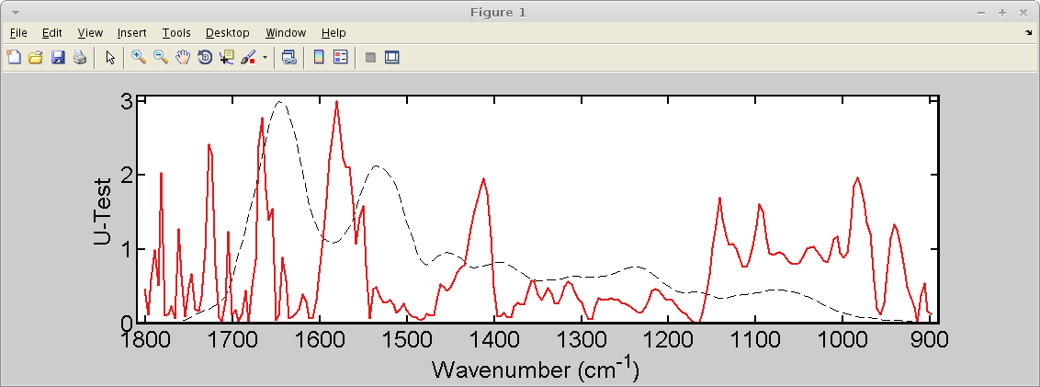

Alternative way
This way has more steps, but the generated figure will have additional elements:
- Non-significant areas hachured in gray
- Significance threshold drawn as a dashed horizontal line

- Click on Dataset
- Click on Apply new blocks/more actions
- Click on AS (Analysis session)
- Click on Using FSG
- Click on Create, train & use
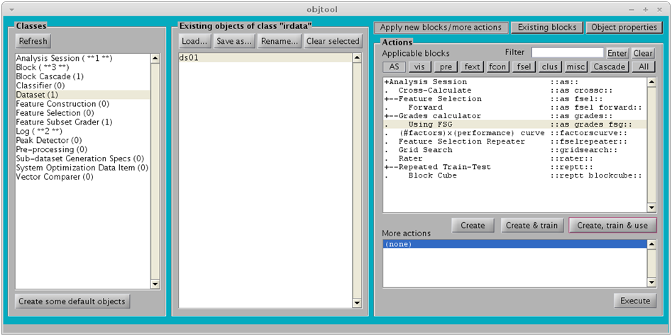
18
16
17
19
20

- FSG: specify fsg_test_u01 created previously
- Click on OK (the result will be a Log)
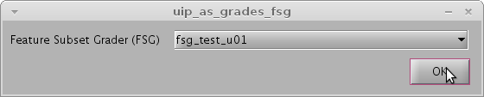

- Click on Log
- Click on Grades-based
- Click on Create, train & use
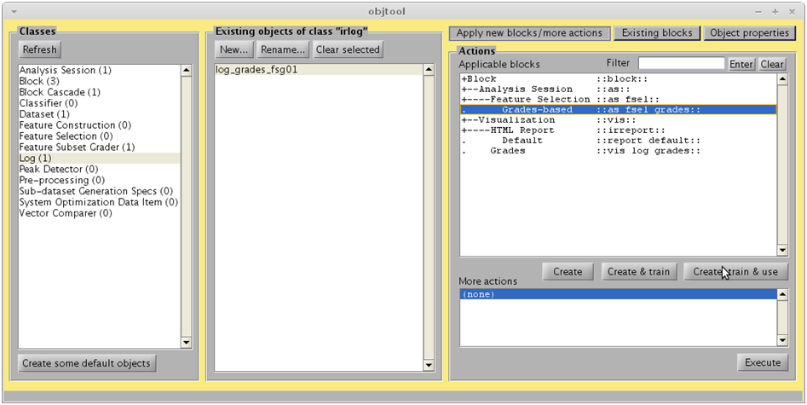
23
24
25

- Selection type: choose By threshold
- Click on OK (The result will be another log)
Note that the Threshold is specified as -log10(0.05), where 0.05 is the significance level. The value –log₁₀(0.05) is approximately equal to 1.3

You can Preview the figure (don’t worry about the “X” marks).
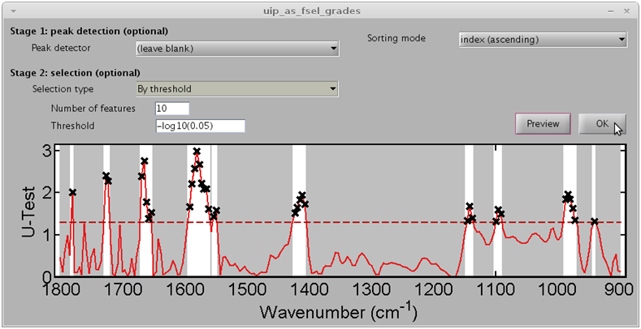
26

- Click on log_as_fsel_grades_grades01
- Click on Features Selected
- Click on Create, train & use
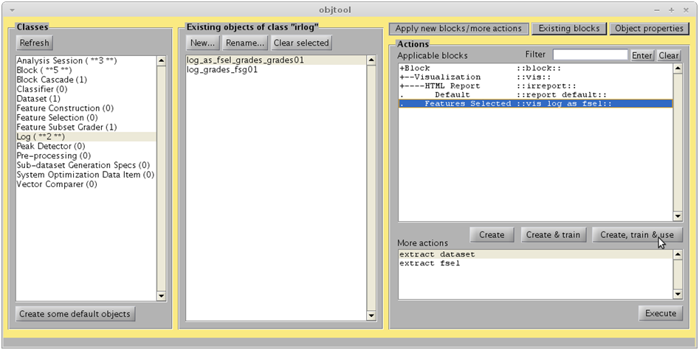
28
29
30

- Dataset for hint is optional. If specified, a dashed black spectrum will be drawn on the background of the figure. The objective is to help with the biochemical interpretation of the U-test per wavenumber curve.
- Uncheck Mark selected features with an “X”
- Click on OK
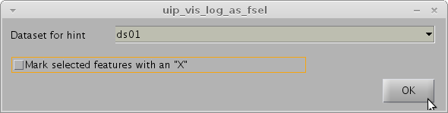

The following figure should appear:
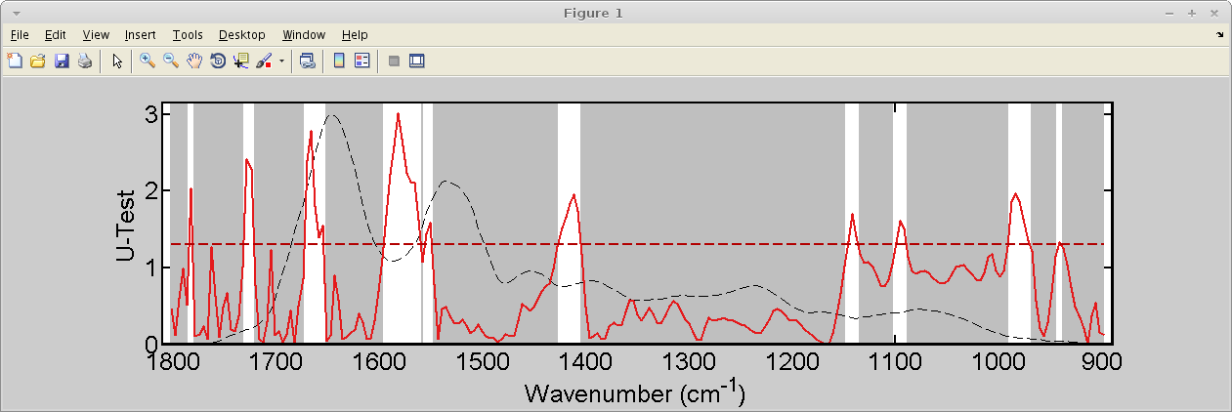

References
[1] K. Gajjar, L. Heppenstall, W. Pang, K. M. Ashton, J. Trevisan, I. I. Patel, V. Llabjani, H. F. Stringfellow, P. L. Martin-Hirsch, T. Dawson, and F. L. Martin, “Diagnostic segregation of human brain tumours using Fourier-transform infrared and/or Raman spectroscopy coupled with discriminant analysis,” Analytical Methods, vol. 44, no. 0, pp. 2–41, 2012.

