IRootLab Tutorials

2-region Pre-processing example
Julio Trevisan
30/November/2012

This document is licensed under a Creative Commons Attribution-NonCommercial-ShareAlike 3.0 Unported License.

Contents
2-region Pre-processing example 1
Contents 1
Introduction 1
Summary of operations 1
Load and visualize data 2
High region (3700-2800 cm⁻¹) 3
Low region (1800-900 cm⁻¹) 5
Merge two datasets column-wise 7
Visualize result 7

Introduction
This tutorial shows how to pre-process two different mid-IR regions separately, and then merge them together into a single dataset.

This tutorial uses Matt’s Nanoparticles Synchrotron data, which is shipped with IRootLab. This dataset has spectra initially in the 4000-900 cm⁻¹ region.

Summary of operations
- Load data
- High region:
  - Cut original to 3700-2800 cm⁻¹ region
  - Rubberband baseline correction
  - Max normalization
- Low region:
  - Cut original to 1800-900 cm⁻¹ region
  - Rubberband baseline correction
  - Amide I peak normalization
- Merge two datasets column-wise

Load and visualize data
- At MATLAB command line, enter browse_demos
- Click on “LOAD_DATA_MATT_NANOPARTICLES_SYNCHROTRON”
- Click on “objtool” to launch objtool
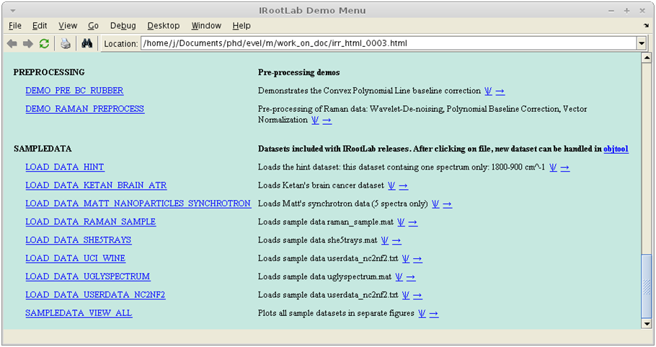
2
3

- Click on vis
- Click on Class means
- Click on Create, train & use
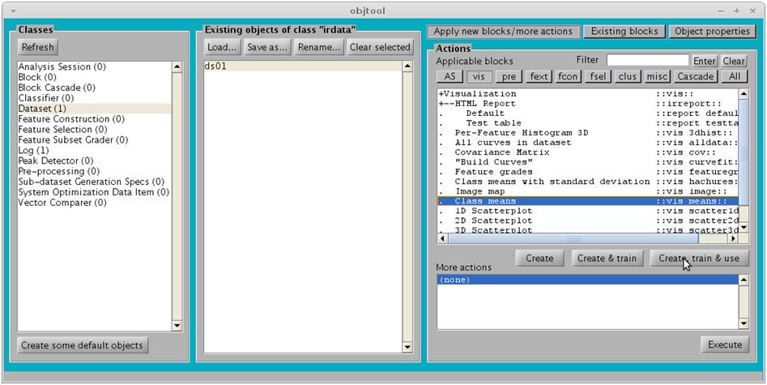
4
5
6

The following figure should appear:
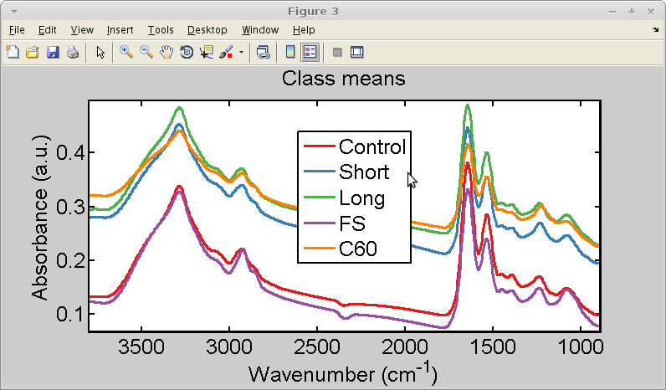

High region (3700-2800 cm⁻¹)
- Click on fsel
- Click on Create, train & use
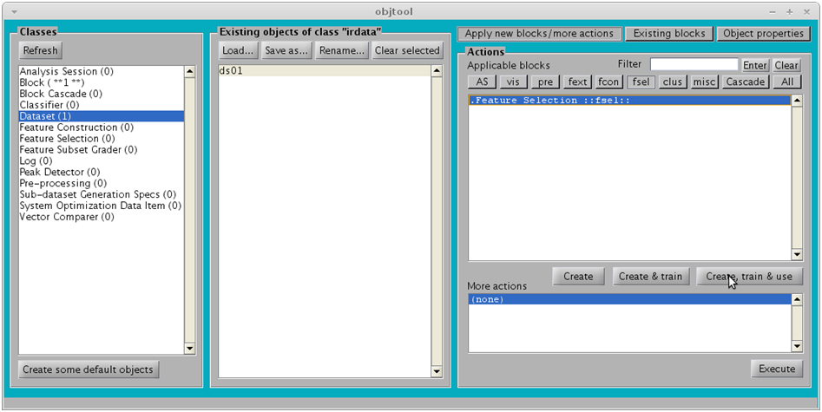
7
8

- Specify region [3700, 2800] (see below)
- Click on OK
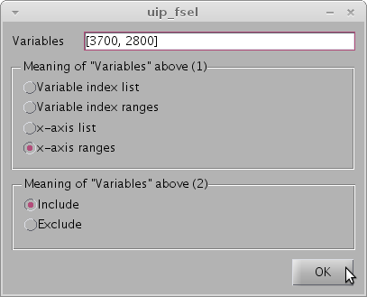

- Click on ds01_fsel01
- Click on pre
- Click on Rubberband-like
- Click on Create, train & use
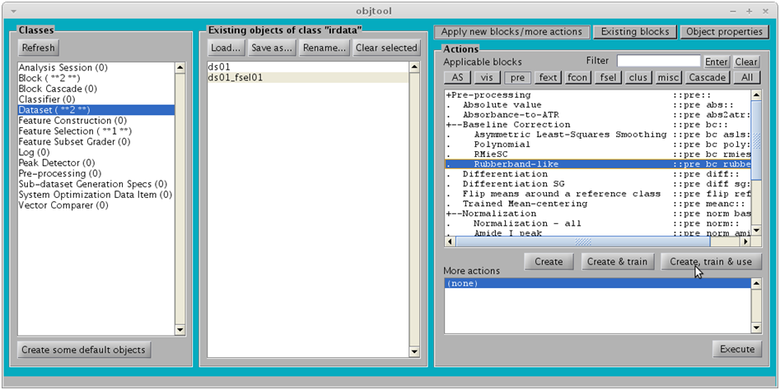
11
12
13
14

- Click on OK

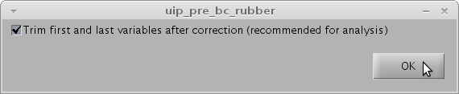

- Click on ds01_fsel01_rubber01
- Click on Normalization-all
- Click on Create, train & use
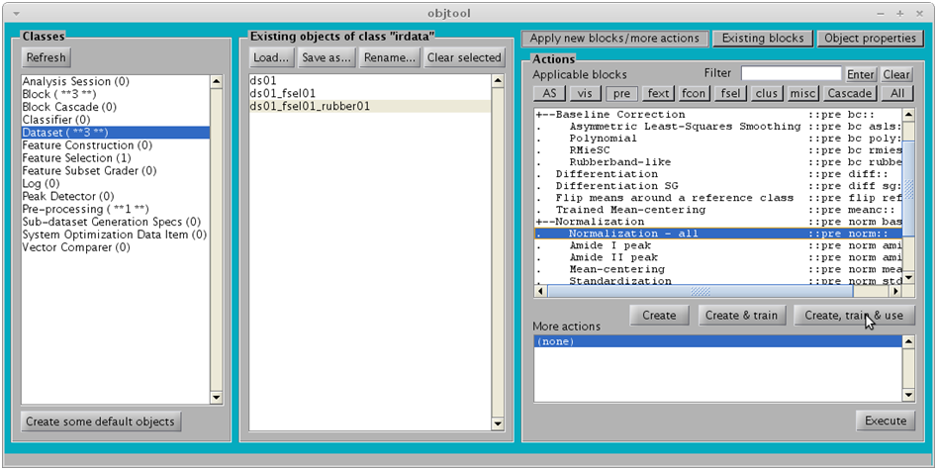
16
17
18

- Click on OK

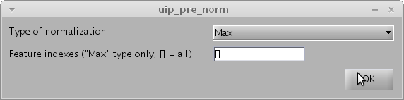

Low region (1800-900 cm⁻¹)
- Click on ds01
- Click on fsel
- Click on Create, train & use
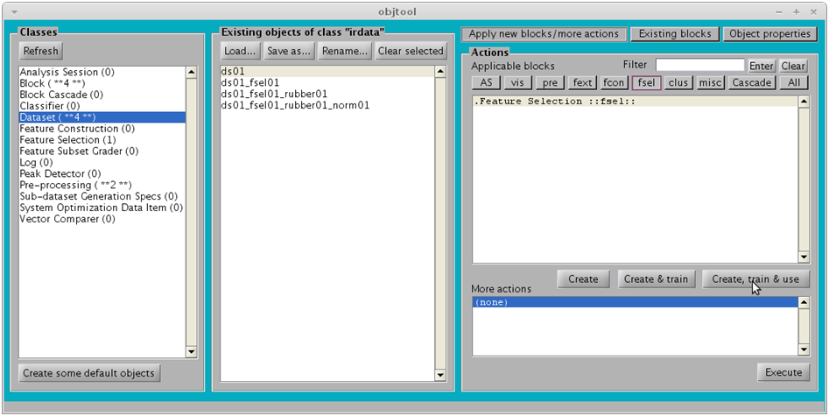
20
21
22

- Accept the default [1800, 900] region (see below)
- Click on OK
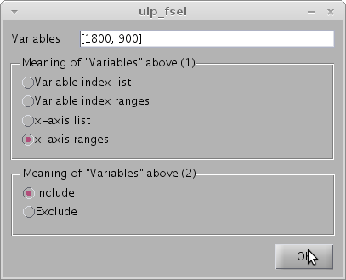

- Click on ds01_fsel02
- Click on Existing blocks (we are going to re-use some blocks)
- Click on pre_bc_rubber01
- Click on Use
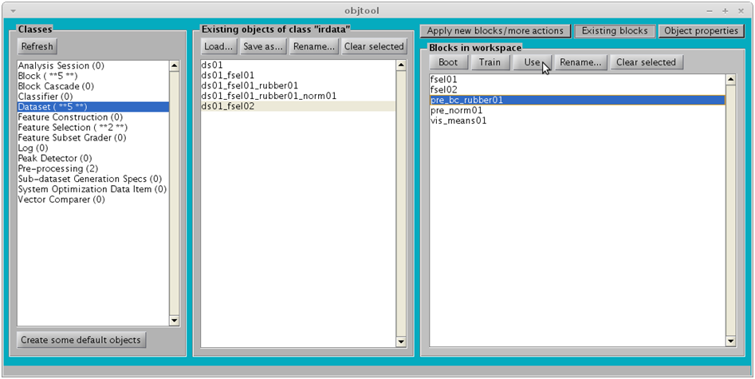
25
27
28
26

- Click on ds01_fsel02_rubber01
- Click on pre_norm01
- Click on Use
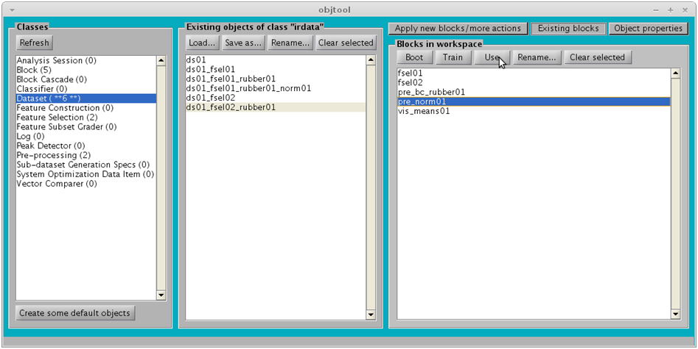
29
30
31

Merge two datasets column-wise
- Hold down the “Ctrl” key to select multiple items
- Select ds01_fsel01_rubber01_norm01 and ds01_fsel02_rubber01_norm01
- Click on Apply new blocks/more actions
- Click on Misc
- Click on Column-wise
- Click on Create, train & use
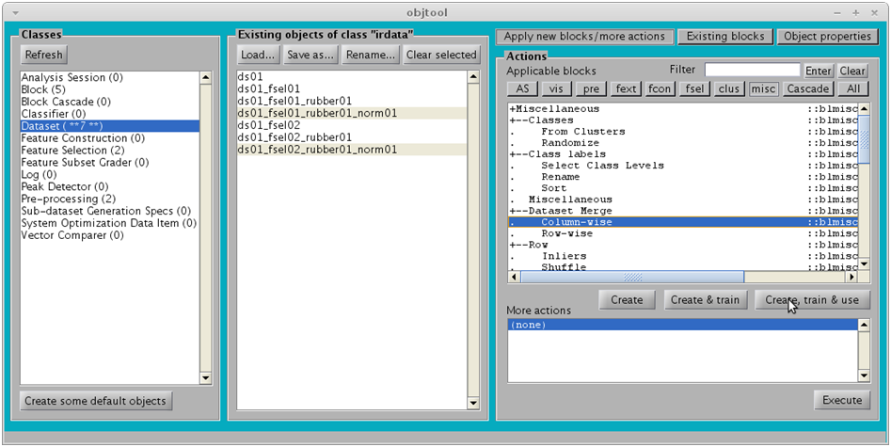
33
35
36
37
34

Visualize result
- Click on irdata_cols01
- Click on Existing blocks (we are going to re-use the class means visualization block)
- Click on vis_mean01
- Click on Use
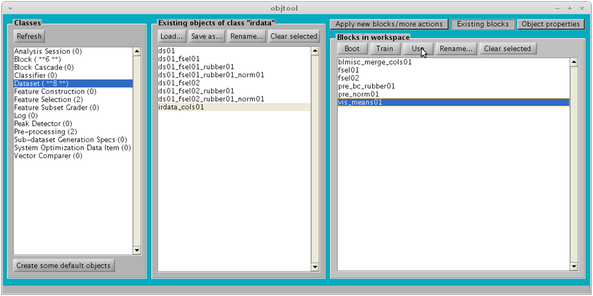
2
1
3
4

The following figure should appear:
