IRootLab - A MATLAB toolbox for vibrational spectroscopy
Manual
Updated on 21/Jul/2017

This document is licensed under a
Creative Commons Attribution-NonCommercial-ShareAlike 3.0 Unported License.

Table of contents
1. Introduction 2
1.1. Overview 2
1.2. This manual 2
1.3. Conventions 3
1.3.1. Formatting styles 3
1.3.2. Terminology and abbreviations 3
1.3.3. Citing IRootLab 3
2. Setup 4
2.1. Installation 4
2.2. Starting IRootLab 4
2.2.1. Windows only 4
2.2.2. All platforms 4
2.2.3. System requirements 4
2.2.4. Platform-specific binaries 4
2.3. Learning resources 4
3. Quick start tutorial 5
3.1. Open and visualize data (Figure 2) 5
3.2. Simple analysis – differences between mean spectra (Figure 3) 5
3.3. Principal components analysis (PCA) (Figure 4) 6
4. Graphical user interfaces (GUIs) 7
4.1.1. Objtool 7
4.1.2. MATLAB Code generation with objtool 9
4.1.3. Supported dataset file types within objtool 10
4.2. Mergetool 11
5. Class library 13
6. Various topics 15
6.1. IRootLab setup file 15
6.2. MATLAB command sheet 15
6.3. Dataset from existing MATLAB variables 15
7. References 16

Introduction

Overview
IRootLab[1] is a framework for vibrational spectroscopy data analysis in MATLAB. It provides pattern recognition, biomarker extraction, imaging, pre-processing, feature extraction, and other methods, directed to vibrational spectroscopy (Fourier-Transform InfraRed (FTIR) and Raman).

The framework includes a class function library, and Graphical User Interfaces (GUIs) to import and analyse data (objtool, mergetool, sheload). The objtool GUI can be also used as a MATLAB code generator. A demonstration page can be opened by typing browse_demos.

IRootLab is Free/Libre and Open-Source software, released under the LGPL licence.

Official website: http://irootlab.googlecode.com

IRootLab contains over 200 hierarchically organized object classes representing concepts, methods and algorithms. The two most important class branches are datasets and blocks. Data analyses are built by training/using blocks with datasets. Block is a very general concept encompassing pre-processing methods, classifiers, visualizations, reports, complex analysis sessions etc. Figure 1 illustrates different types of blocks with code examples using the IRootLab library.

Datasets and blocks
Dataset
Block
Modified
dataset
Dataset
Visualization
Block
Figure

Training dataset
Block
1- Training stage
Trained
block
Dataset
(same or other)
Trained
block
2- Use stage
Modified
dataset
Blocks that don’t require training
Visualization blocks
Blocks that require training
Code example
% Rubberband baseline correction
block = pre_bc_rubber();
ds02 = block.use(ds01);
% Class means visualization
block = vis_means();
figure;
block.use(ds01);
% PCA-LDA
block = cascade_pcalda();
block.blocks{1}.no_factors = 10; % PCA factors
block = block.boot();
block = block.train(ds01);
ds02 = block.use(ds01);
Code example
Code example

Figure 1 – Illustration of different types of blocks with code examples using the IRootLab library.

This manual
This manual explains the structure of IRootLab and discusses some of the most important details about the toolbox. Basic MATLAB knowledge is expected from the reader (MATLAB current directory, workspace, how to specify a MATLAB vector). Aspects of object-oriented programming (OOP) were concentrated in Section 5 and avoided elsewhere to spare readers who are mostly interested in using the GUIs.

The “official” IRootLab documentation remains the source code itself, and the Doxygen-generated documentation from there (http://bioph.lancs.ac.uk/irootlabdoc). However, the official documentation is for reference, rather than for learning. This manual provides selected, concentrated and relevant information.

Conventions

Formatting styles
The following styles are used throughout this manual:

name of a file

MATLAB code

MATLAB code

Some option available in a graphical interface

Note

Terminology and abbreviations

class | The word “class” may be used meaning either  - data class (pattern classification), such as “control”, “cancer” etc, or  - object class (object-oriented programming).  The meaning should be clear from the context.
group | = sample/patient/colony/specimen etc  A “group” represents all spectra that must be kept together at all times if the dataset is split, because they all belong to the same sample/patient/colony/specimen etc.
observation | = row  Refers to a row in a dataset matrix. May be a spectrum, but can be also an average spectrum, a set of PCA scores etc
feature | = data variable  Refers to a column in a dataset matrix. May be a wavenumber, a PCA factor etc
no | “number of observations” = number of rows in a dataset matrix
nf | “number of features” = number of columns in a dataset matrix
AS | Analysis Session
SGS | Sub-dataset Generation Specification
FSG | Feature Subset Grader

Citing IRootLab
If IRootLab works well for you and you use it for your respective study and publication, please cite the following:

- http://irootlab.googlecode.com (please mention the website in your manuscript)

[1] Trevisan, J., Angelov, P.P., Scott, A.D., Carmichael, P.L. & Martin, F.L. (2013) "IRootLab: a free and open-source MATLAB toolbox for vibrational biospectroscopy data analysis". Bioinformatics 29(8), 1095-1097. doi: 10.1093/bioinformatics/btt084.

[2] Martin, F.L., Kelly, J.G., Llabjani, V., Martin-Hirsch, P.L., Patel, I.I., Trevisan, J., Fullwood, N.J. & Walsh, M.J. (2010) "Distinguishing cell types or populations based on the computational analysis of their infrared spectra". Nature Protocols 5(11), 1748-1760. doi:10.1038/nprot.2010.133

Setup
This chapter gives information to get IRootLab running.

Installation
Download the most recent ZIP file from http://irootlab.googlecode.com and extract the file to a directory of your choice.

Starting IRootLab

Windows only
- Open the Windows Explorer
- If you are starting a new project, create a directory for your project e.g., […]/My Documents/brain_project
- Locate the directory created when the ZIP file was extracted
- Double-click on the file named startup_windows
- Change MATLAB Current folder to your own project directory.

All platforms
- If you are starting a new project, open Windows Explorer and create a directory for your project e.g., […]/My Documents/brain_project
- Start MATLAB
- Change MATLAB Current folder to the directory containing the IRootLab library extracted from the ZIP file (this directory should contain a file called startup.m)
- In MATLAB command line, enter startup
You should see a list of directories being added to the path, then a welcome message.
- Change MATLAB Current folder to your own project directory.
Note
Alternatively, you can use MATLAB "Set path..." (add with subdirectories). This will keep you from having to run startup every time you start MATLAB. However, make sure you remove the old directories from the MATLAB path when you download a new version of IRootLab.

System requirements
IRootLab will run under MATLAB, which is ported for Windows, Linux, and MacOS. The oldest MATLAB version tested was r2007b.

MATLAB toolboxes:
- (optional) MATLAB Parallel Computing Toolbox (PCT)
- MATLAB Wavelet Toolbox for Wavelet de-noising

Platform-specific binaries

This information is only relevant if you intend to use SVM or the MySQL database.
- SVM classifier (LibSVM): LibSVM was successfully compiled for Windows 32-bit/Windows 64-bit; Linux 32-bit/64-bit.
- MySQL connector (mYm): mYm was currently compiled Windows 32-bit; Linux 32-bit/64-bit. Linux 64-bit: libmysqlclient.so.16 and libmysqlclient.so.18.

Learning resources
- Tutorials and this manual: http://irootlab.googlecode.com . There are currently about 8 step-by-step analysis tutorials on-line covering various topics.
- Demo files: type browse_demos
- On-line documentation (reference): http://bioph.lancs.ac.uk/irootlabdoc
- Access to reference from MATLAB command line: help2 <filename>
- Context-sensitive help from IRootLab GUIs: press F1

Quick start tutorial
This simple tutorial aims to get you started with using objtool, which is the main GUI. It will use Ketan’s Brain ATR data[3], which is included in the toolbox.

Open and visualize data (Figure 2)
- Run the steps on Section 2.2 to start IRootLab
- At MATLAB command line, enter browse_demos
- Scroll down the page
- Click on the “LOAD_DATA_KETAN_ATR” hyperlink
- Click on the “objtool” hyperlink to launch objtool
- Click on Apply new blocks/more actions
- Click on vis
- Click on Class means
- Click on Create, train & use
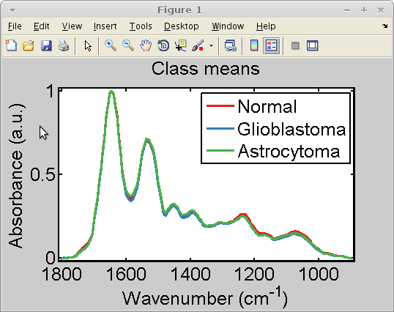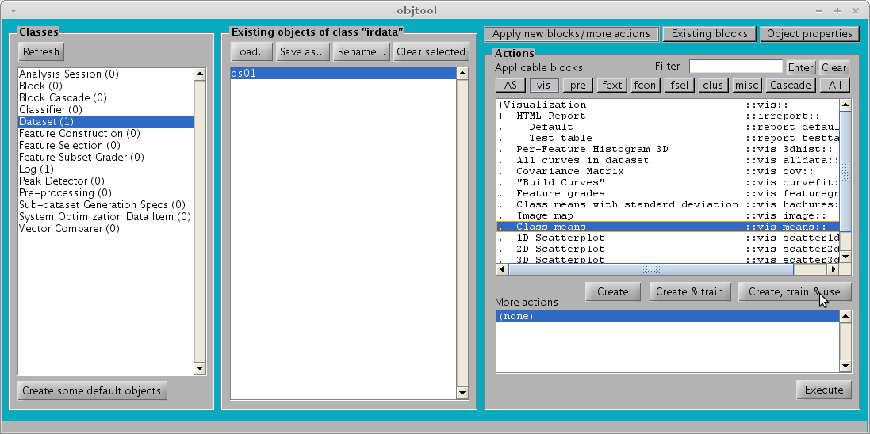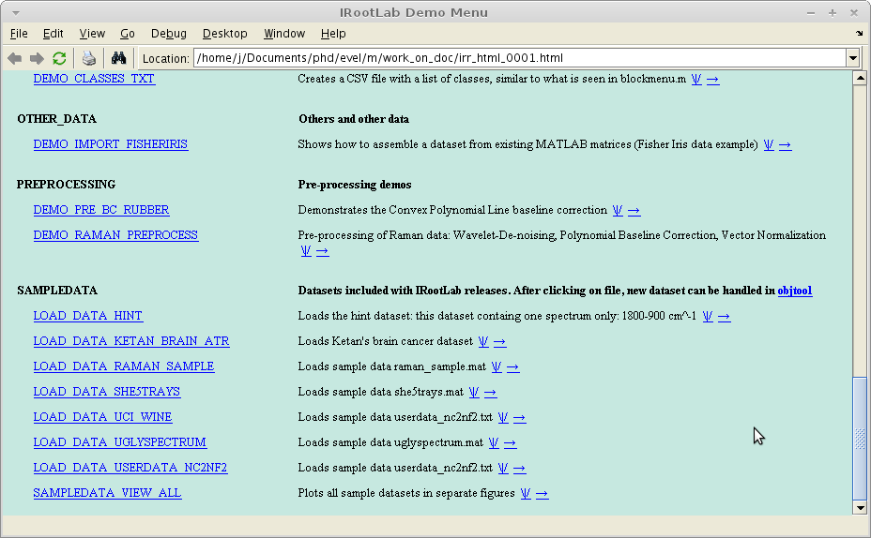
4
5
6
7
8
9
Figure 2 – Tutorial – Open and visualize data in objtool

Simple analysis – differences between mean spectra (Figure 3)
At this part, we will compare the mean spectra of the “Glioblastoma” and “Astrocytoma” classes against the “Normal” class. The latter is used as a reference class to investigate changes in infrared absorption in the two former.

- Click on pre
- Click on Subtract mean of a reference class
- Click on Create, train & use
- A parameters window appears; click on OK (“1” is already the first class of the dataset; “Normal”)
- Click on ds01_refmean01
- Click on vis
- Click on Class means
- Click on Create, train & use
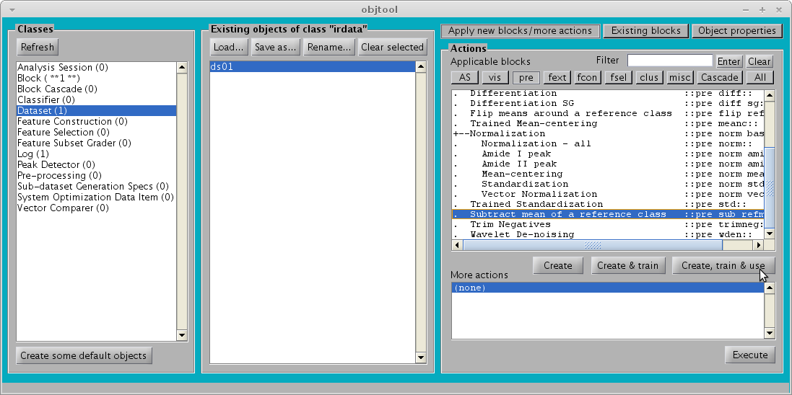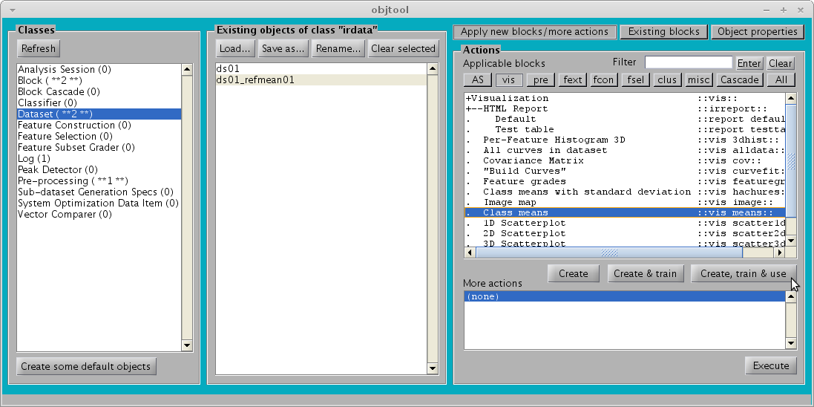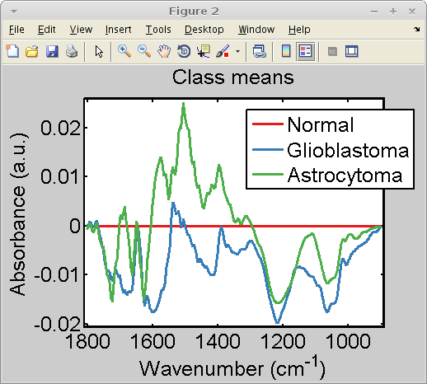
10
12
11
15
16
17
14
Figure 3 – Tutorial – Differences between mean spectra

Principal components analysis (PCA) (Figure 4)
This part of the analysis investigates whether PCA can segregate the data classes.

- Click on ds01
- Click on fcon
- Click on Principal component analysis
- Click on Create, train & use
- A parameters window appears; click on OK to accept the default options
- Click on ds01_pca01
- Click on vis
- Click on 2D Scatterplot
- Click on Create, train & use
- On the window that appears, enter [1, 2, 3] as the Indexes of variables to plot. Click on OK
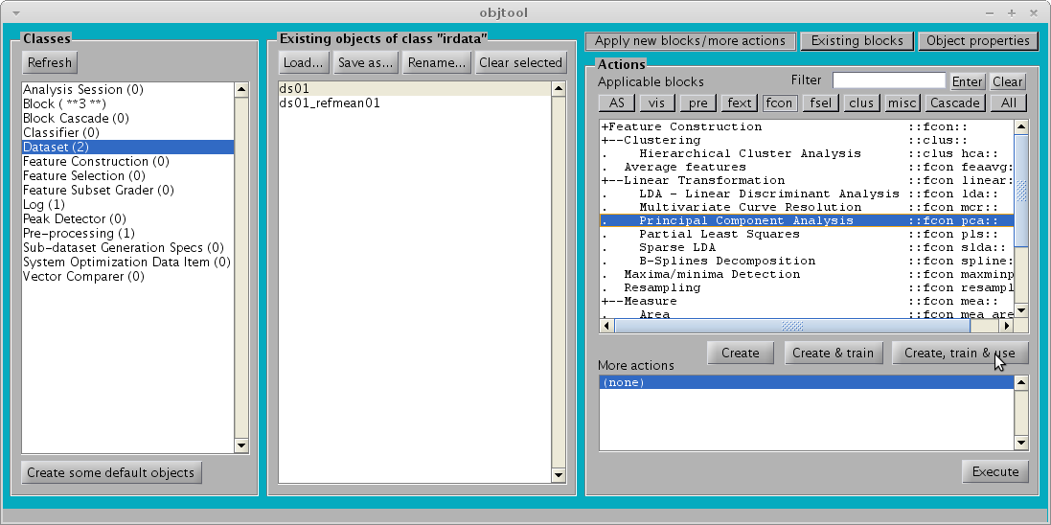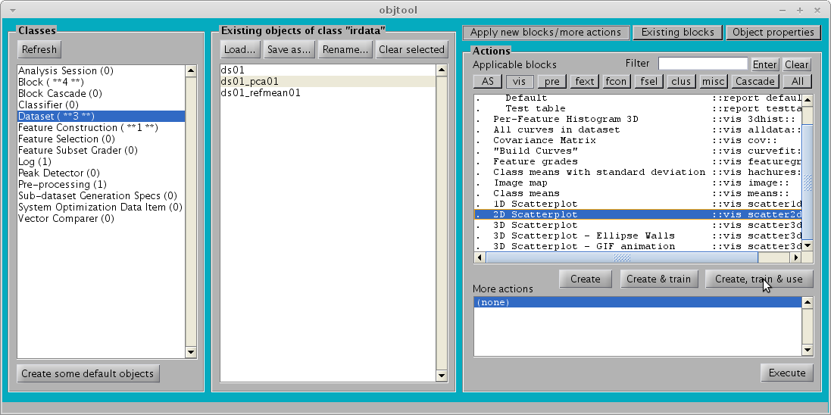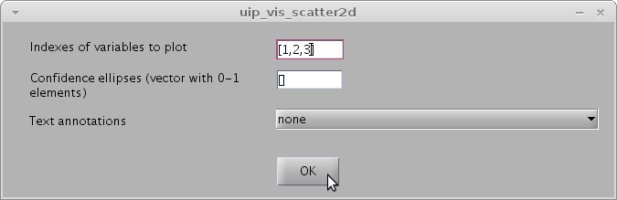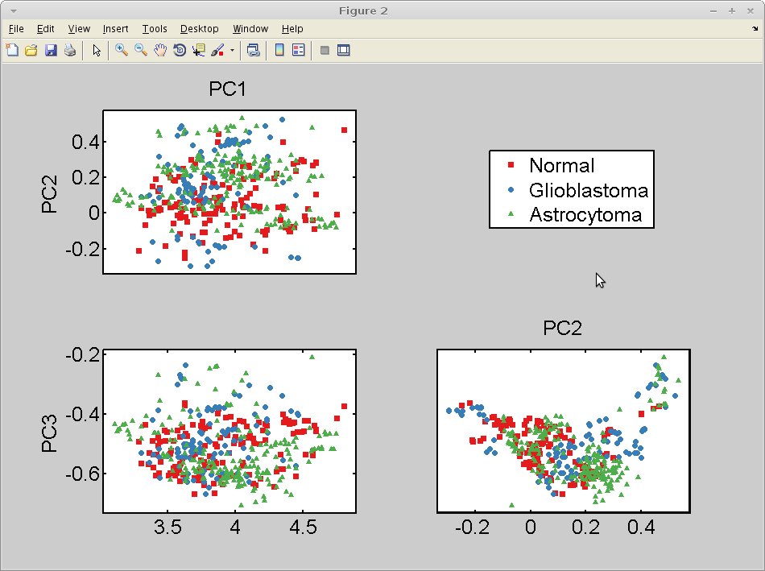
19
21
20
18
24
25
26
23
27
Figure 4 – Tutorial – PCA

Graphical user interfaces (GUIs)
IRootLab has four GUIs callable from MATLAB command line (Table 1).

Table 1 – IRootLab GUIs.
GUI name | Purpose
objtool | This is the most important GUI. Used for data analysis, general manipulation of objects, and code generation
mergetool | Tool to assemble dataset from a multiple spectral files containing one spectrum each
irootlab | Launch other GUIs, get help, and view auto-generated MATLAB code
sheload | Loads dataset from online database[4]

The GUIs read and write variables directly into the MATLAB workspace.

Objtool
The main objtool “missions” are:
- Create objects or load datasets
- Boot, train and use blocks
- Execute objects “more actions”
- Automatically generate MATLAB code from any of the above

The look of objtool and its visible options will vary depend on selected items and toggled buttons. The most notorious change is the colour of the window background, which reflects which class is selected in the left panel.

The objects listed in objtool are variables present in MATLAB workspace, created by objtool itself, by mergetool, by sheload or by other means (e.g., user scripts). Every processing step leaves existing objects untouched and creates new ones, adding to the new variable name a suffix that reminds of the operation that has just been carried out. For example, in Figure 5 ds01_std01 is the result of the standardization of dataset ds01; then, ds01_std01_lda01 is the result of applying LDA to ds01_std01. objtool is divided in three areas, as seen in Figure 5.
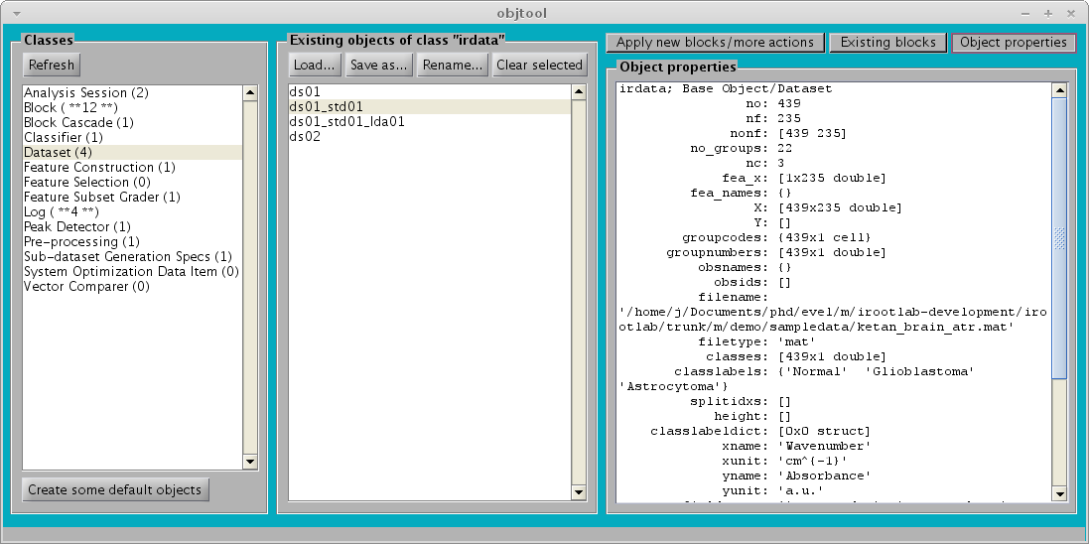
Left panel/
Classes panel
Middle panel/
Objects panel
Right panel

Figure 5 – Screenshot of objtool

Left panel
The left panel is a selector for what to show in the middle panel. It also shows how many object of each class exists in the MATLAB workspace. A trick helps identify objects that were just created by the last operation: when a number is surrounded by asterisks (“**”), it means that new objects of that class have just appeared as a result of the last user operation.

Middle panel
This panel shows the existing objects of the class selected on the left panel. The buttons at the top vary slightly depending on the selected class: for irdata, the Load… and Save as… buttons appear, whereas for the other classes, the New… button appears instead.

Right panels
There are three different panels on the right. The panel to appear is selected by one of three toggle buttons on the top right.

The first of the right panels is the Apply new blocks/more actions panel (Figure 6). The Applicable blocks list shows only the classes that accept the object(s) that are selected in the middle panel as input. There are three options when creating a block in this way: Create only; Create & train; and Create, train & use. The More actions list is dependent on the selected object in the middle panel. “More actions” are simple actions available to some objects only (mainly to extract some information from an object).

The Existing blocks panel (Figure 7) shows all blocks already in the workspace that are applicable to the object(s) that is (are) selected in the middle panel. The Train and Use operations will pass whichever is selected in the middle panel as input to the block.

Finally, the Object properties panel shows MATLAB-generated description for the selected object. Figure 8 shows this panel when a dataset is selected in the middle panel. Some objects have associated additional information. For example, a cascade block (class block_cascade_base) will show the descriptions of its component blocks, apart from its own description.

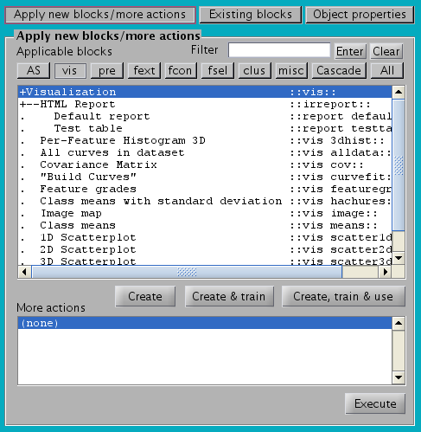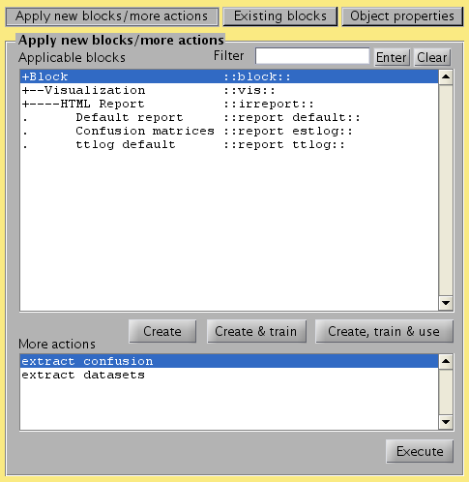
A
B
Figure 6 – (A) Apply new blocks/more actions panel when the Dataset class is selected in the left panel; (B) Apply new blocks/more actions panel when a class other than a dataset is selected in the left panel. The main difference is set of buttons that appear only for the Dataset class.
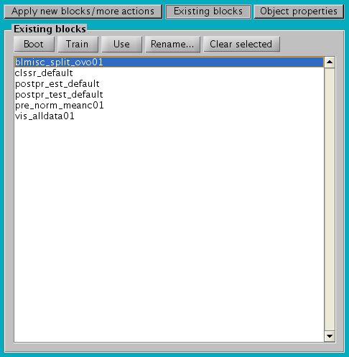
Figure 7 – Existing blocks panel in objtool

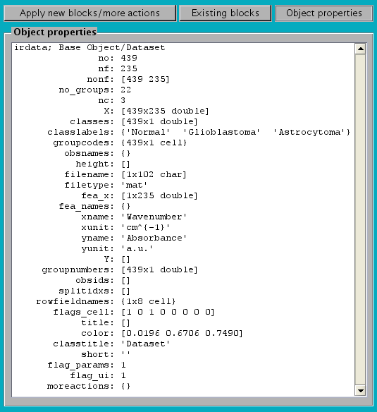
Number of observations/(data rows)
Number of features/(data columns)
Number of groups (e.g., patients)
Number of data classes
Data matrix, dimension no×nf
Classes, column vector of size no
Class labels
Group codes, (e.g., patient names)
Dataset properties
Figure 8 – Object properties panel showing the properties of a dataset. Some properties are described. irdata is circled, which is the object class name for a dataset. All properties are explained in the reference, which is accessible by typing help2 irdata at MATLAB command window (or directly at the source file by typing edit irdata.m). The same applies to other object classes.

MATLAB Code generation with objtool
A major feature of objtool is its ability to generate MATLAB code. Every analysis step done in objtool is recorded as MATLAB code into a file named irr_macro_[nnnn].m, which can be opened by entering ircode_edit at MATLAB command window.

This resource was created to help with script/function/class writing, and it is highly efficient in doing so. For example, the demo files were almost completely created in this way, and a substantial part of IRootLab itself was automatically coded by objtool.

Code generation can easily help users to repeat the same analysis sequence on a different dataset, or batch-process several datasets.

Supported dataset file types within objtool
Table 2 shows the file types currently supported in objtool. Directory demo/sampledata has some examples of data files of all types.
Table 2 - file types supported in objtool.
File type | Read? | Write? | Comment | Related OOP-class file
TXT (basic) | Yes | Yes | Figure 9 | dataio_txt_basic.m
TXT ("Pirouette-like") | Yes | Yes | Figure 9 | dataio_txt_pir.m
TXT (IRootLab) | Yes | Yes | Figure 10; Only TXT format that saves all dataset properties | dataio_txt_iroot.m
TXT (IrootLab with labelled classes) | Yes | Yes | Figure 11; Fills the “classes” column with the class labels, not numbers | dataio_txt_iroot2.m
MAT | Yes | Yes | MATLAB compressed binary: short file size; opens fast | dataio_txt_mat.m
OPUS image maps | Yes | No | FPA images only, not point maps | dataio_opus_nasse.m
TXT (LibSVM format) | No | Yes | LIB | dataio_opus_libsvm.m
The TXT (IRootLab) format is the only text format that saves all the properties of a dataset. There are two variants of the TXT (IRootLab) format. The first variant (Figure 10) saves the classes as integer numeric values starting at zero, and has a “classlabels” row in the file containing the labels respective to each number; the second variant (Figure 11; named IRootLab with labelled classes when you “Save as…” in objtool) does not have the “classlabels” row, and fills in the “classes” column directly with the labels instead. We recommend the second variant, as it is easier to edit and avoid confusion. You can choose between these variants when you “Save as…” in objtool.
The TXT (basic) can only store spectra and their associated classes.
The TXT (Pirouette-like) stores the wavenumbers, sample codes, spectra, and classes.
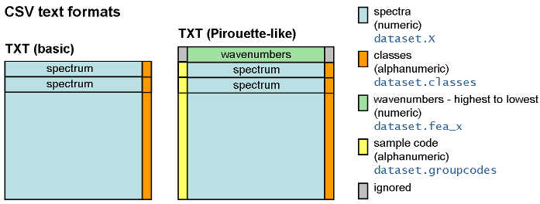
Figure 9 - Basic and Pirouette-like text formats

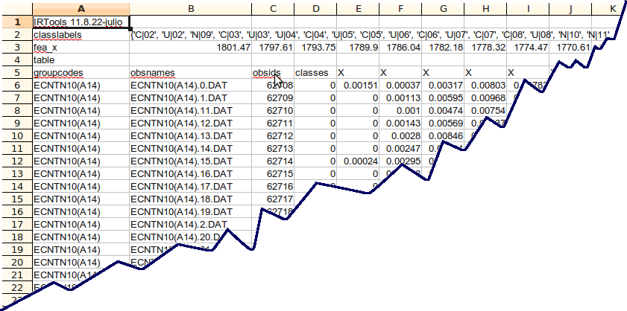
Figure 10 - IRootLab text format (first variant)

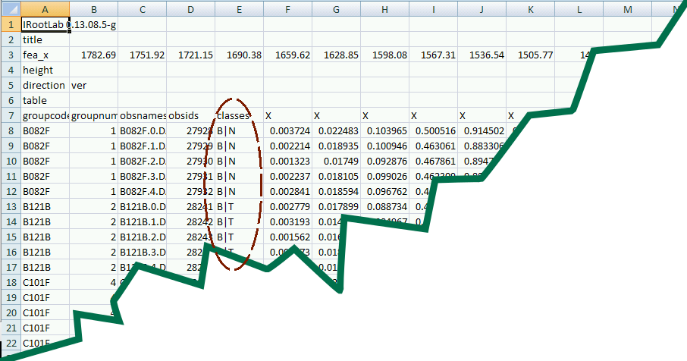
Figure 11 – IRootLab with labelled classes text format (second variant)

Mergetool
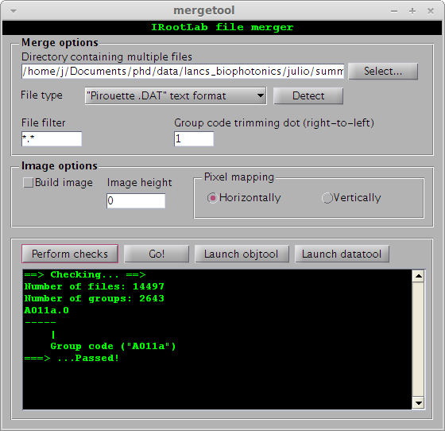
Figure 12 – Screenshot of mergetool.
mergetool is a tool to merge several spectral files into a new dataset. The new dataset is created in the MATLAB workspace and can be immediately viewed in objtool. Table 3 shows the spectral file types currently supported in mergetool. A spectral file type auto-detection button is available.
Table 3 - Spectral file types supported in mergetool.
Spectral File type
Pirouette .DAT
OPUT binary
Wire TXT (Renishaw)
Wire (2016) TXT(Renishaw)
Diane's "Another FTIR" (2017) TXT
BWSpec CSV

Usage is nearly straightforward. Only the meaning of the Group code trimming dot (right-to-left) parameter may be slightly obscure. This parameter is a way to tell what part of the file name will be considered to be the code for a data group (i.e., sample/patient etc). It is common for many spectra be taken from the same sample/group. The spectral files are often sequentially named by the spectrum acquisition software (e.g., OPUS (Bruker Optik GmbH) creates files such as sample.0, sample.1, sample.2 etc). Within mergetool, the dots (“.”) in the file names are considered to be “dividers”. So, the Group code trimming dot (right-to-left) specifies how many dots to skip (from right to left) to compose the group code; the group code will start at the beginning of the file name and stop just before the specified dot (Figure 12). The Perform checks button gives a report that, among other things, gives a preview of what a group code will be before the files are imported.

For image maps, the Image height needs to be specified. Naturally, this number must be able to divide the total number of spectral files (such quotient will be the image width). The image map is mounted as follows. The first spectrum in the directory (sorted by name) will be the bottom left pixel of the image (Figure 13).
Image map
First file in directory
(sorted by name)
Second file
. . .

Vertically
Horizontally
First file in directory
(sorted by name)
Second file
.
.
.

Figure 13 – mergetool file reading sequence to compose image map, depending on how the Pixel mapping option is set.

Class library
IRootLab contains more than 200 object classes hierarchically organized. The classes are data models and implementations of analysis methods, concepts and algorithms. Parts, concepts or techniques that are common to many methods have been implemented separately (e.g., sgs, fsg). This provides flexibility and avoids code repetition. The most important class branches, with their corresponding descriptions, are shown in Table 1. A full listing can be obtained by running the demo file demo_classes_html.
Table 4 – Some important branches and leaves from the IRootLab class tree.
Class (.m file name) | Description
Dataset (irdata) | Datasets for analysis can be point spectra or image maps. The only difference between these is that image maps have the height property set to a value > 0.  Classifiers output a special kind called an “estimation dataset” (class estimato). These datasets have their classes unset and need to be processed by a decider.  A final special dataset is generated by hierarchical clustering. In this case, the variables represent cluster numbers (class irdata_clus).
Block (block) | This is the base class for all processing operations.  A block is an object containing the boot(), train(), and use() methods, and a few more properties to define how the block class will be handled by objtool.
Miscellanea (blmisc) | Miscellanea blocks lack a common identity; they have been grouped for convenience to display grouped in objtool.
Visualization (vis) | Figure and report (HTML) generation
Cascade block (block_cascade_base) | Cascade blocks encapsulate a sequence of blocks.  Cascade blocks can mimic the behaviour of linear transformation blocks (fcon_linear; such as PCA) if it contains one or more such blocks. It has all the properties that a fcon_linear block has, however its valid functioning will depend on the component blocks.  The loadings matrix is calculated by multiplying the loadings matrix of successive component blocks.  When a cascade block is about created in the GUI, it will call the parameters GUIs of its component blocks in sequence.  Customized/frequent sequences can be created by inheriting the block_cascade_base class.
Decider (decider) | This is an abstraction of class decisions based on the posterior probabilities calculated by a classifier. Classifiers generate an estimato dataset which is later processed by a decider. If the highest per-class posterior probability is below the decider decisionthreshold property, it will “refuse to decide”, assigning to the data row a class of -1 instead of a valid one.
Classifier (clssr) | A classifier is a block whose use() method outputs an estimato dataset.
Ensemble (aggr) | Various classifier ensemble architecture
Incremental (clssr_incr) | Classifiers capable of incremental learning. Such classifiers train0 method uses one data row at a time to modify the classifier internal structure.
Fuzzy Rule-Based Model (frbm) | Contains a set of parameters that allow various fuzzy classifier to be set up, including eClass0 and eClass1[5]
Feature Extraction (fext) | IRootLab uses Guyon et al.’s division of feature extraction between feature selection and feature construction methods[6].
Feature Construction (fcon) | Methods that combine variables (linearly or non-linearly) into new ones
Hierarchical Clustering (clus_hca) | Clustering was placed under feature construction because it creates a new dataset whose features represent cluster numbers.
Linear Transformation (fcon_linear) | Blocks with loadings vectors to transform the input dataset
Measure (fcon_mea) | Measure over the entire row (e.g., norm, maximum, minimum etc), creates output that contains one variable only (i.e., the measuse).
Feature Selection (fsel) | Feature selection. This block is not trainable. It contains a fixed vector of feature indexes to be selected from the input to use(). Feature selection methods are found under “Analysis Session” (as class)
Pre-processing (pre) | This branch contains methods that are classically called “pre-processing” methods in the literature, such as de-noising, baseline correction and normalization [7–9].
Analysis Session (as) | These blocks usually perform complex and potentially time-demanding analyses inside their use(), and the use() output is a irlog (not a dataset as is the output of most blocks) from where many results can be extracted and/or visualized.
Sub-dataset Generation Specs (sgs) | This class is an abstraction of sub-dataset generation. Sub-dataset generation is needed nearly everywhere in data analysis. Situations include obtaining train and test datasets, cross-calculation of scores, and as part of algorithms (e.g. bagging and boosting). sgs centralizes the task of calculating the rows to be extracted from a dataset to generate sub-datasets.
Feature Subset Grader (fsg) | fsg centralizes the task of calculating a “grade” (a measure of for a sub-set of features). This class was created to be used in feature selection algorithms.
Peak Detector (peakdetector) | This class centralizes the work of detecting peaks from a spectrum, loadings vector, histogram etc.
Vector Comparer (frbm) | This class is used to compare vectors with the same number of elements (paired tests). The main application is for comparison between classifiers (see report_sovalues_comparison.m).
Log (irlog) | This is a general information/results container. It stores information whose format is unsuitable to be stored by a irdata object. Typically generated by as::use().

Various topics

IRootLab setup file
IRootLab configuration for colour scheme, font, scatterplot markers etc is stored as MATLAB global variables. These variables are automatically saved by objtool in a file called irootlab_setup.m, which can be changed at will. Each project directory has its own irootlab_setup.m file. You can force the creation of this file by entering setup_write at MATLAB command window.

To open the setup file, enter edit irootlab_setup at MATLAB command window. To make changes to this file immediately available in MATLAB environment, simply execute the file (e.g., by pressing the F5 key at MATLAB editor; or entering irootlab_setup at MATLAB command window). Table 5 describes some setup options. For a complete reference to IRootLab global variables, please check assert_all.m
Table 5 - some global/irootlab_setup.m setup variables.
Variable name | Purpose
SCALE | Controls the relative size of text, markers, and line widths.  Tip: Increase the SCALE if you want a figure to be small in a publication. For example, if SCALE = 1 looks fine when you create a full-width figure panel, you should use SCALE = 2 for a half-width panel.
COLORS | Defines a colour sequence to represent different data classes. Each colour is coded as a 3-element vector representing its [Red, Green, Blue] (RGB) composition. Each values ranges from 0 to 255. For example, [255, 0, 0] is red, [0, 0, 0] is black, and [255, 255, 0] is yellow (red+green).  Tip: There is a good website at http://www.colourlovers.com with lots of nice colour palettes!
MARKERS | Sequence of markers (triangles, circles, squares etc) to represent different data classes in scatterplots.  Tip: For a list of available marker symbols, enter help plot at MATLAB command window.
FONT | Font name
FONTSIZE | Font size

MATLAB command sheet
IRootLab-specific
v_x2ind([1650, 1450, 1080], ds01.fea_x) | Converts wavenumbers to feature indexes for dataset ds01.
save_as_png([], "filename.png”, 300) | Saves current figure as a PNG file named filename.png at 300 dpi resolution.
edit_ircode | Opens the current auto-generated macro MATLAB editor
help2 | Opens main page of documentation in browser
help2 irdata | Opens help in browser for file irdata.m
objtool  mergetool  sheload | Opens respective GUIs
ds01.classlabels’ | Shows class labels from dataset ds01
MATLAB basics
1:5 | Same as [1, 2, 3, 4, 5]
1:2:21 | Same as [1, 3, 5, 7, 9, 11, 13, 15, 17, 19, 21]
xlim([900, 1800]) | Sets current figure x-axis limits to 1800-900 cm-1 region. Note that the lower value comes first in the command.
ylim([0, 1]) | Sets current figure y-axis limits between 0 and 1.
var(ds01_meanc01_pca01.X, 1)’ | Displays Variances of principal components (assuming that the dataset name is ds01_meanc01_pca01)

Dataset from existing MATLAB variables
If you already use MATLAB for data analysis, you are likely to have at some stage the dataset variables, such as X and classes separately. The example below shows how to pack such existing variables into an IRootLab dataset.

% Assumes that these variables exist:
% - X of dimension [no]x[nf]
% - classes of dimension [no]x[1]

ds = irdata();
ds.X = X;
ds.classes = classes;
ds = ds.assert_fix(); % Automatically fills in the classlabels property with defaults

Also, check the file called demo_import_fisheriris.m; this example performs some analysis on Fisher’s Iris dataset that is shipped with MATLAB and performs a somewhat more advanced than the example above.

References
[1] J. Trevisan, P. P. Angelov, A. D. Scott, P. L. Carmichael, and F. L. Martin, “IRootLab: a free and open-source MATLAB toolbox for vibrational biospectroscopy data analysis.,” Bioinformatics (Oxford, England), pp. 1–2, Mar. 2013.
[2] F. L. Martin, J. G. Kelly, V. Llabjani, P. L. Martin-Hirsch, I. I. Patel, J. Trevisan, N. J. Fullwood, and M. J. Walsh, “Distinguishing cell types or populations based on the computational analysis of their infrared spectra,” Nat. Prot., vol. 5, no. 11, pp. 1748–1760, Jan. 2010.
[3] K. Gajjar, L. D. Heppenstall, W. Pang, K. M. Ashton, J. Trevisan, I. I. Patel, V. Llabjani, H. F. Stringfellow, P. L. Martin-Hirsch, T. Dawson, and F. L. Martin, “Diagnostic segregation of human brain tumours using Fourier-transform infrared and/or Raman spectroscopy coupled with discriminant analysis,” Analytical Methods, vol. 5, pp. 89–102, 2013.
[4] J. Trevisan, P. P. Angelov, I. I. Patel, G. M. Najand, K. T. Cheung, V. Llabjani, H. M. Pollock, S. W. Bruce, K. Pant, P. L. Carmichael, A. D. Scott, and F. L. Martin, “Syrian hamster embryo (SHE) assay (pH 6.7) coupled with infrared spectroscopy and chemometrics towards toxicological assessment,” Analyst, vol. 135, no. 12, pp. 3266–3272, Dec. 2010.
[5] P. P. Angelov and X. Zhou, “Evolving Fuzzy-Rule-Based Classifiers From Data Streams,” IEEE T. Fuzzy Syst., vol. 16, no. 6, pp. 1462–1475, Dec. 2008.
[6] I. Guyon, S. Gunn, M. Nikravesh, and L. A. Zadeh, Feature Extraction - Foundations and Applications. New York: Springer, 2006.
[7] R. L. Somorjai, M. Alexander, R. Baumgartner, S. Booth, C. Bowman, A. Demko, B. Dolenko, M. Mandelzweig, A. E. Nikulin, N. J. Pizzi, E. Pranckeviciene, and P. Summers, RZhilkin, “A data-driven, flexible machine learning strategy for the classification of biomedical data,” in Artificial Intelligence Methods And Tools For Systems Biology, vol. 5, W. Dubitzky and F. Azuaje, Eds. Dordrecht: Springer Netherlands, 2004, pp. 67–85.
[8] R. M. Jarvis and R. Goodacre, “Genetic algorithm optimization for pre-processing and variable selection of spectroscopic data,” Bioinformatics, vol. 21, no. 7, pp. 860–868, Apr. 2005.
[9] J. Trevisan, P. P. Angelov, P. L. Carmichael, A. D. Scott, and F. L. Martin, “Extracting biological information with computational analysis of Fourier-transform infrared (FTIR) biospectroscopy datasets: current practices to future perspectives.,” The Analyst, vol. 137, no. 14, pp. 3202–15, Jul. 2012.

See irobj.color property.
See block::inputclass property.

